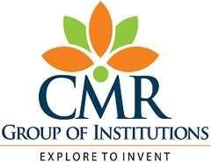

## A PBL PROJECT

On

**QR CODE GENERATOR**

Submitted By:

|  |  |
| --- | --- |
| **B. SHIVAMANI**  **B. MALATHI**  **Y. KARTHIK**  **D. VISHNU VARDHAN**  **K. JOSHNA** | **218R1A1208 218R1A1213**  **218R1A1229**  **218R1A1216**  **218R1A1232** |

Under the Guidance of:

**Mr. B. SRINIVAS REDDY**

Assistant Professor, Department of IT

**DEPARTMENT OF INFORMATION TECHNOLOGY**

CMR ENGINEERING COLLEGE

**UGC AUTONOMOUS** (Approved by AICTE-New Delhi & J.N.T.U, Hyderabad) Kandlakoya (v), Medchal Road, Hyderabad-501 401, Telangana State, India.



**CERTIFICATE**

This is to certify that the project entitled “**QR CODE GENERATOR”** is a bonafide work of carried out by:

|  |  |
| --- | --- |
| B. SHIVAMANI  B. MALATHI  Y. KARTHIK  D. VISHNU VARDHAN  K. JOSHNA | 218R1A1208 218R1A1213  218R1A1229  218R1A1216  218R1A1232 |

In the part of innovative teaching methodology **PBL (Project Based Learning)** of Python Programming Laboratory under our guidance and supervision.

|  |  |
| --- | --- |
| **Project Coordinator**  **Mr. B. Srinivas Reddy**  Assistant Professor,  Department of IT,  CMR Engineering Collage,  Hyderabad | **Head of the Department**  **Dr. Madhavi Pingili**  Professor & HOD,  Department of IT,  CMR Engineering Collage, Hyderabad |

**DECLARATION**

This is to certify that the work reported in the present project entitled **“QR CODE GENERATOR”** is a record of bonafide work done by us in the Department of Information Technology, CMR Engineering College, Hyderabad. The reports are based on the project work done entirely by us and not copied from any other source. We submit our project for further development by any interested students who share similar interests to improve the project in the future. The results embodied in this project report have not been submitted to any other University or Institute for the award of any degree or diploma to the best of our knowledge and belief.

|  |  |
| --- | --- |
| **B. SHIVAMANI**  **B. MALATHI**  **Y. KARTHIK**  **D. VISHNU VARDHAN**  **K. JOSHNA** | **218R1A1208**  **218R1A1213**  **218R1A1229**    **218R1A1216**  **218R1A1232** |

**ACKNOWLEDGEMENT**

We are extremely grateful to our Principal, **Dr. A. Srinivasula Reddy,** and our HOD, **Dr. P. Madhavi**, Department of IT, CMR Engineering College for their constant support. We are immensely thankful to **Mr. B. Srinivas Reddy**, Assistant Professor, Project Coordinator, Department of IT, for his constant guidance, encouragement and moral support throughout the project. We will be failing in duty if we do not acknowledge with gratitude thanks to the authors of the references and other literate referred to in the project. We express our thanks to the Department of Information Technology, CMR Engineering College and friends for all the help and co-ordination extended in bringing out this project successfully in time. Finally, we are very much thankful to our parents who guided us for every step.

|  |  |
| --- | --- |
| **B. SHIVAMANI**  **B. MALATHI**  **Y. KARTHIK**  **D. VISHNU VARDHAN**  **K. JOSHNA** | **218R1A1208**  **218R1A1213**  **218R1A1229**    **218R1A1216**  **218R1A1232** |

**TABLE OF CONTENTS**

|  |  |
| --- | --- |
| **CONTENT** | **PAGE NUMBER** |
| DECLARATION | 3 |
| ACKNOWLEDGEMENT | 4 |
| ABSTRACT | 6 |
| INTRODUCTION | 7 |
| HARDWARE AND SOFTWARE REQUIREMENTS | 8 |
| ALGORITHM | 9 |
| SOURCE CODE | 10 |
| OUTPUT SCREEN | 11 |
| CONCLUSION | 12 |
| REFERENCES | 13 |

**ABSTRACT**

The project aims to enhance participants' understanding of Python programming concepts and practical application while developing a functional and user-friendly QR code generation tool. The QR code generator project utilizes the popular Python programming language, allowing participants to explore its various libraries and modules. The project involves designing an interactive command-line interface (CLI) or a graphical user interface (GUI) application that accepts user inputs and generates QR codes accordingly.

Throughout the project, participants will gain knowledge and hands-on experience in the following areas:

* Python programming: Participants will learn and utilize Python's core functionalities, such as data types, loops, conditionals, and functions, to develop the QR code generator application.
* QR code generation: Participants will delve into the principles and specifications of QR code generation. They will leverage third-party libraries like qrcode to generate QR codes based on user input, such as URLs, text, or contact information.
* User interface design: Depending on the chosen approach (CLI or GUI), participants will learn about designing user-friendly interfaces.
* Error handling and validation: To ensure the application's robustness, participants will implement error handling techniques and input validation. They will address potential issues such as invalid inputs, file handling errors, or QR code generation failures.
* Testing and debugging: Participants will acquire skills in testing and debugging Python applications. They will implement unit tests using frameworks like unittest to verify the functionality and integrity of the QR code generator.

By actively engaging in this PBL project, participants will not only enhance their Python programming skills but also gain practical experience in developing real-world applications. The QR code generator project serves as an excellent platform for participants to understand the fundamentals of Python, explore QR code generation concepts, and s trengthen their problem-solving abilities.

**INTRODUCTION**

The QR code, short for Quick Response code, has become a ubiquitous presence in our digital lives. From product packaging to marketing campaigns, QR codes offer a convenient way to share information and connect with users. In this project, we delve into the world of QR codes and embark on a Problem-Based Learning (PBL) journey to develop a QR code generator using Python.

The primary objective of this PBL project is to equip participants with practical skills in Python programming and empower them to build a QR code generator application. By engaging in hands-on development, participants will explore different aspects of Python, such as data types, control structures, functions, and libraries.

In the following sections, we will explore the various aspects of this PBL project, including the implementation of the QR code generator, the user interface design, error handling techniques, and testing methodologies. Together, we will embark on an exciting journey into the world of Python programming and QR code generation.

**FUNCTIONAL REQUIREMENTS**

**HARDWARE REQUIREMENTS:**

* Processor - Quad core 2GHZ or Higher
* RAM - 4 GB minimum recommended
* Hard Disk - 25 GB SSD/HDD

**SOFTWARE REQUIREMENTS:**

* Operating System - Windows 10/11
* Language - Python
* Software - IntelliJ IDEA

**ALGORITHM**

1. Start
2. Import the required libraries:
   1. - Import the `qrcode` library for generating QR codes.
   2. - Import the `image` library for working with images.
3. Initialize the QRCode object:
   1. - Create a `QRCode` object using the `qrcode.QRCode()` constructor.
   2. - Set the desired parameters such as the version, box size, and border of the QR code.
4. Specify the data for the QR code:
   1. - Assign the data or content that you want to encode into the QR code to the `data` variable. In this case, it is a URL.
5. Generate the QR code:
   1. - Use the `make()` method of the `QRCode` object to generate the QR code.
   2. - Set the `fit` parameter to `True` to automatically adjust the QR code size based on the data.
6. Create the QR code image:
   1. - Use the `make_image()` method of the QRCode object to create the QR code image.
   2. - Specify the `fill` parameter to set the color of the QR code modules (e.g., "black").
   3. - Specify the `back_color` parameter to set the background color of the QR code (e.g., "white").
7. Save the QR code image:
   1. - Use the `save()` method of the image object to save the generated QR code image to a file.
   2. - Provide the desired filename and extension (e.g., "test.png").
8. Scan the QR code in your mobile, you can get the content of the url which you have given.
9. Stop.

**SOURCE CODE**

import qrcode

import image

qr = qrcode.QRCode(

version = 15,

box_size = 10,

border = 5

)

data="https://www.w3schools.com/python/"

qr.add_data(data)

qr.make(fit = True)

img = qr.make_image(fill="black",back_color = "white")

img.save("test.png")

**OUTPUT SCREEN**

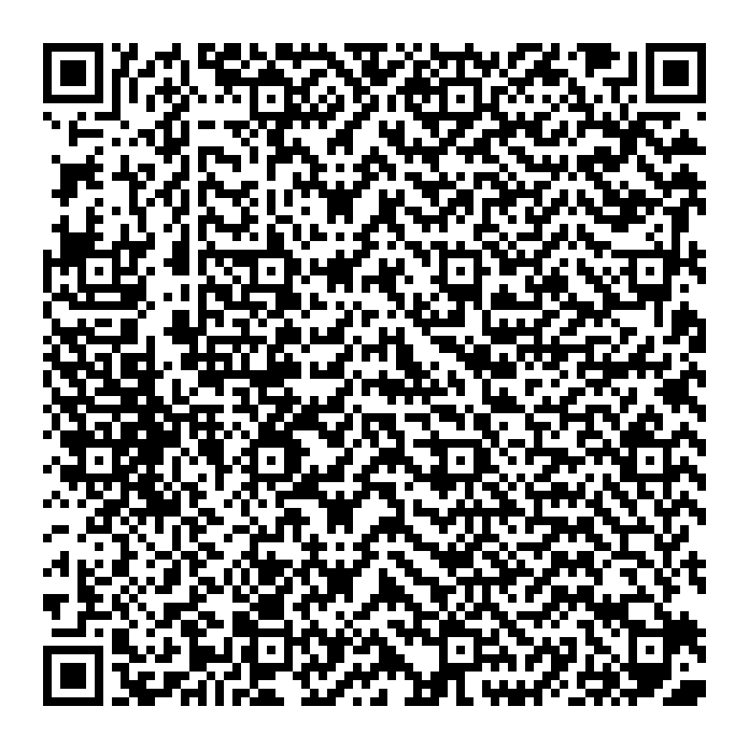

**CONCLUSION**

In conclusion, the QR code generator PBL project using Python offers a practical and engaging learning experience for participants. Throughout the project, we have been exposed to key Python programming concepts and gained hands-on experience in developing a functional QR code generator application.

Overall, the QR code generator PBL project provided us with a comprehensive learning experience, combining theoretical knowledge with practical implementation. It empowered us to apply Python programming concepts, explore third-party libraries, and develop real-world applications. The acquired skills and experience gained from this project will undoubtedly serve well in our future endeavors in software development and problem-solving

**REFERENCES**

* <https://www.javatpoint.com/generate-a-qr-code-using-python>
* <https://www.geeksforgeeks.org/generate-qr-code-using-qrcode-in-python/>
* <https://www.w3schools.com/python/>

THANK YOU!